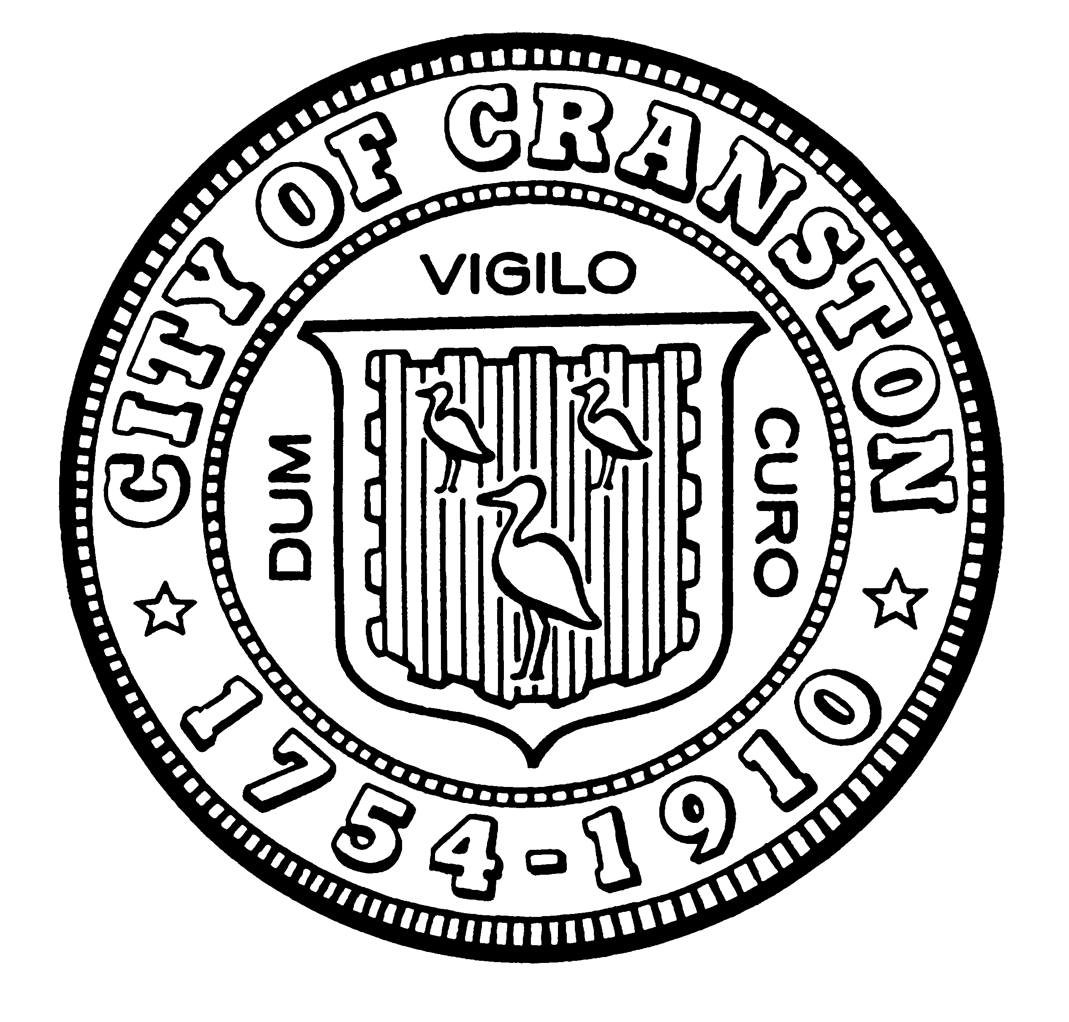

HOUSING COMMISSION

Annette Mann Bourne, Chair
Robert Santurri Jr, OneCranston Health Equity Zone, Vice Chair
Amy Rainone, Secretary
Ernest Tommasiello, Director, Department of Community Development
Jason Case
Frank DiZoglio III
Joanne McGunagle, CCAP
Jason M. Pezzullo, Planning Director
Derik Tutt

WEDNESDAY JANUARY 4, 2023 @ 5:30 P.M.
Cranston City Hall, 869 Park Avenue
3rd Floor Conference Room

MONTHLY MEETING- NOVEMBER AGENDA

- Approval of minutes of December 7, 2022 meeting (for vote)
- Election of officers (for vote)
- Approval of 2023 meeting schedule (for vote)
- Discuss requesting update from the City Council on ARPA expenditures and reiterating priorities for housing related spending (for discussion and possible vote)
- Discuss next steps for working with the Council on ADU ordinance and with the Planning Department on the Development of the City’s Comprehensive Plan. (for discussion)
- New business (for discussion)

“Individuals requesting interpreter services for the hearing-impaired must notify the Office of the City Clerk at 461-1000 Ext. 3197 seventy-two (72) hours in advance of the hearing date.”

